https://learn.wqu.edu/my-path/courses/ai-lab01/modules/ai-lab1-project1/tasks/but-what-is-a-neural-network

There are three layers are in neural network, input, hidden, output
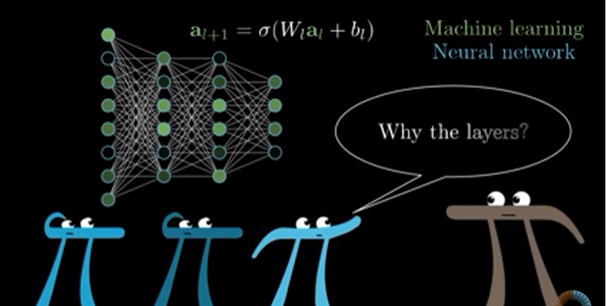

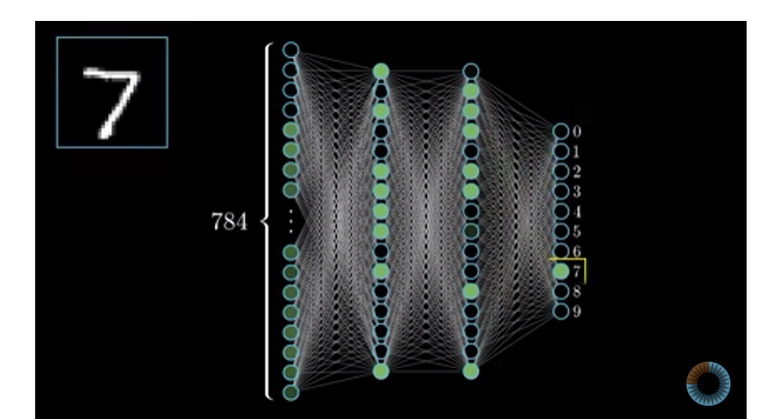



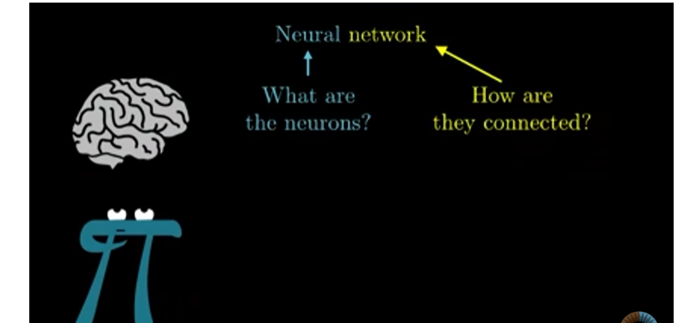

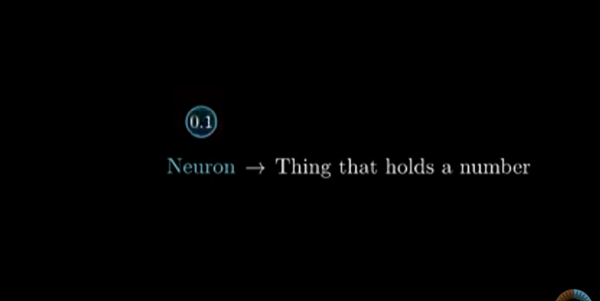

Here 784 is the number hold by neuron
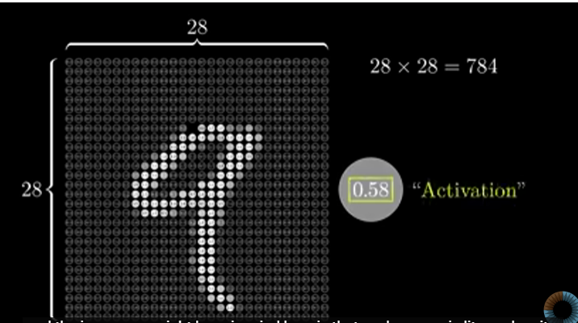
This neuron will separated into differen layers
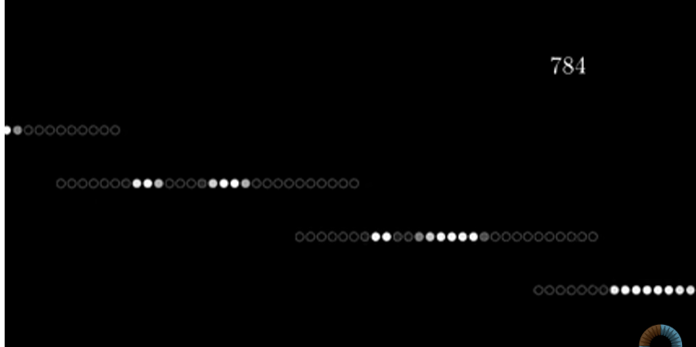
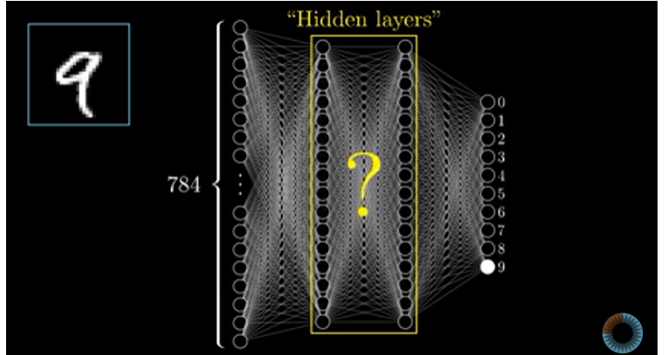

Hidden layers may differ from neuron types, basically it holds set of patterns to find the number once it finds a similar pattern that has some part of number 9 then that will be considered as activation functions, that activation becomes input to the next layers
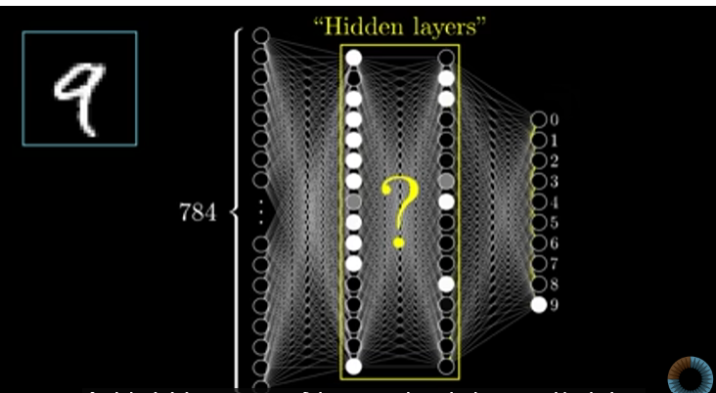

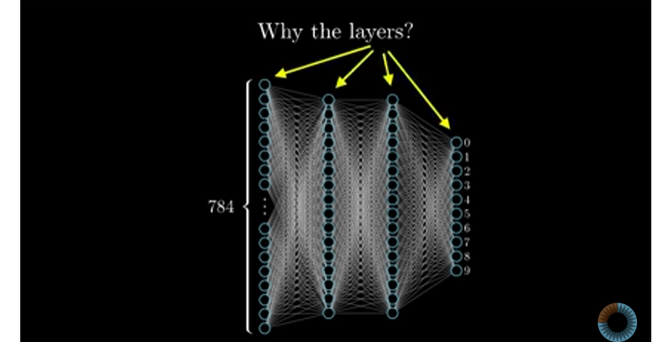
In each layer there will be a pattern below one
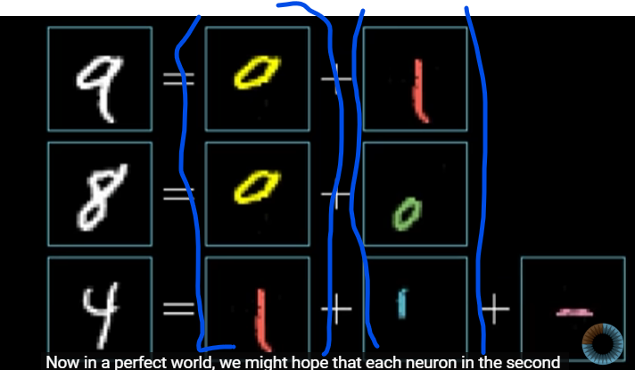
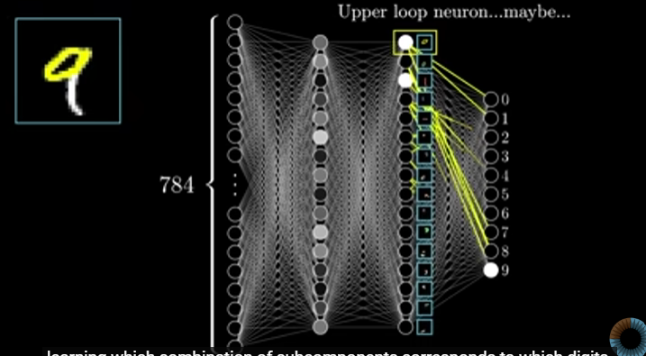

On second layer it will have little edges
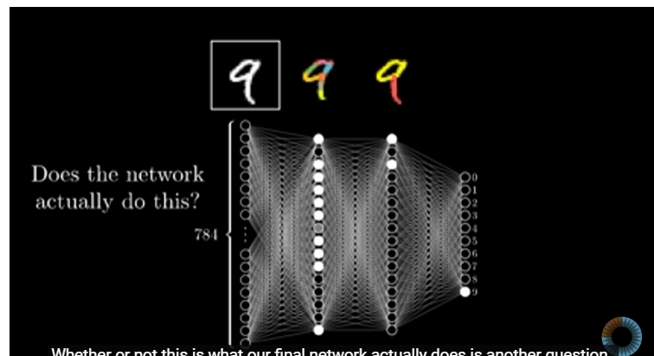

The process between each layer as follows, there will be weight passed from one layer to another layer all, to recognize the right hand side picture it has white dots in some parts when the any of the first layer’s pattern are matches with the picture on right hand side that becomes activation function, those activation function’s weight (highlighted in green) will be calculated to find the other accurate part of the image, in the formula a is the activation functions and w is the weight
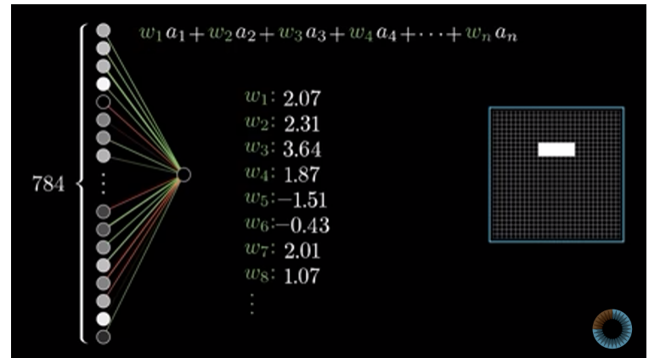

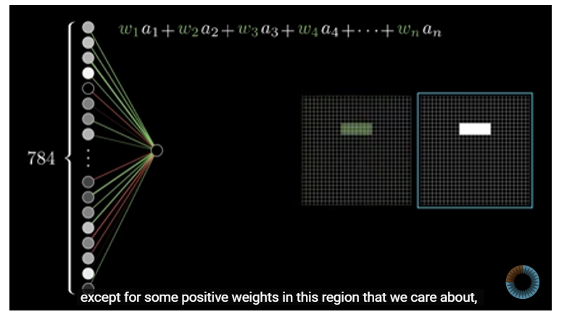
The sum of all weight and activation function will be 0 – 1, so for this sigmoid are used here also know as logistic curve.

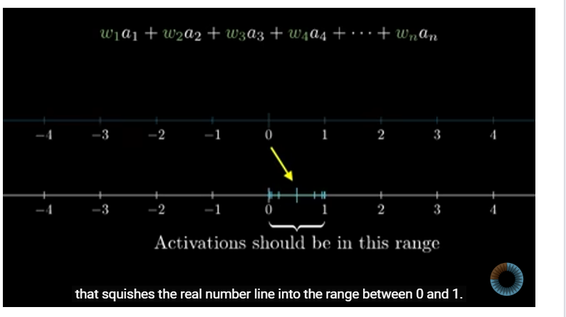

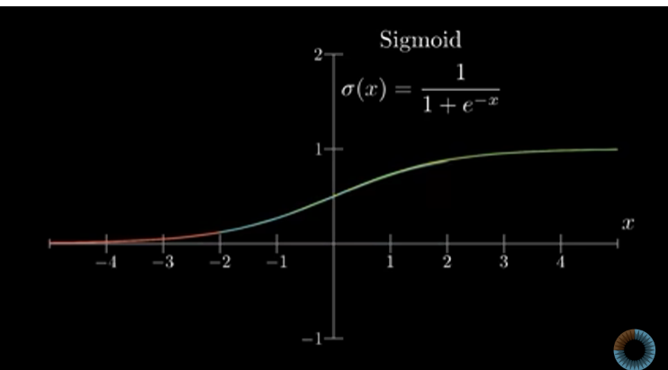

So sigmoid checks how positive the sum of weight and activation function is.
Bias is a number that helps to modify the activation function condition, for above we have the condition that a function should be activate if the weighted sum is greater than 0, we can modify the condition by adding the bias value to the sigmoid function, so weight tells what pattern to be recognized on next layer to find the actual image, and bias tells you what sum of weight a function should have to become activation function
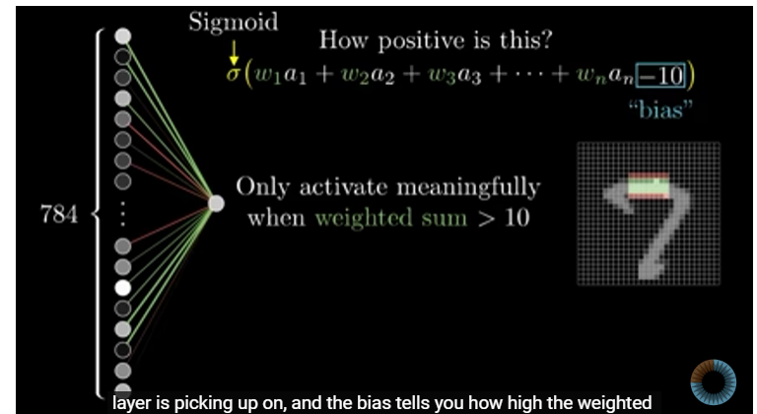

WHAT IS COST FUNCTION IN NURAL NETWORK?
The cost function drives the learning process in a neural network by:
- Quantifying prediction errors.
- Guiding parameter updates via optimization.
- Facilitating the improvement of the model's predictions over time.
Without a cost function, there’s no way for the network to measure or improve its performance.
A cost function (also called a loss function) that measures how well the network is performing. The network is then trained by minimizing this cost function using the method of gradient descent.

In some time trained neural model may get confuse and will give a lot of output instead of one accurate output, in the below image it gives all the values as output instead of one value that is 3, this is the situation where the cost function plays it’s role.
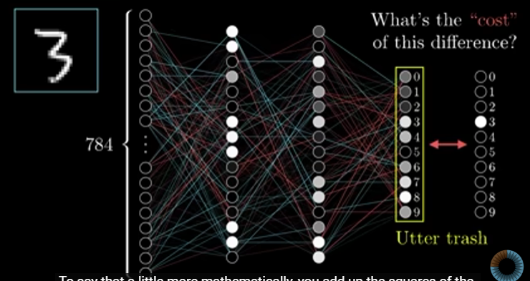

Cost will be find by adding square to all the training output values showed on below image
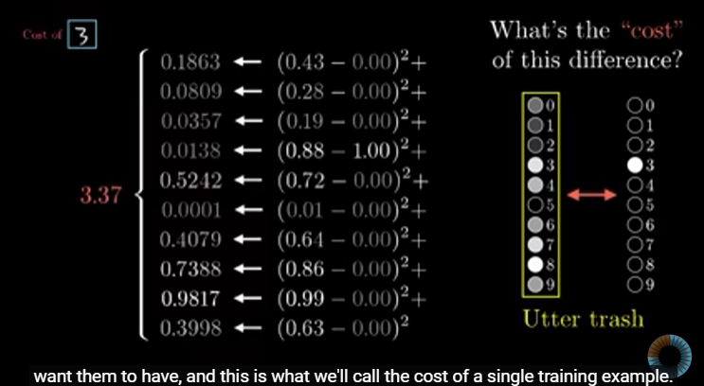

On training the network it might have several cost values, each training will have this cost value, to improve the network performance to find the accurate result all training’s cost value will be taken from that we find the average cost value
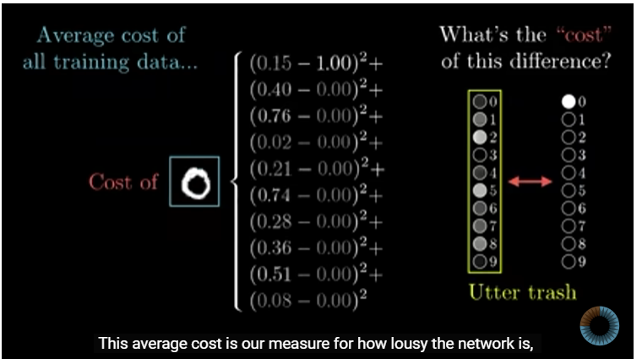

A cost function will take weights and bias values of all activation network as it’s parameter and produce one single value (average) that tells how bad the network to predict accurate result, so the learning network should minimize this cost function
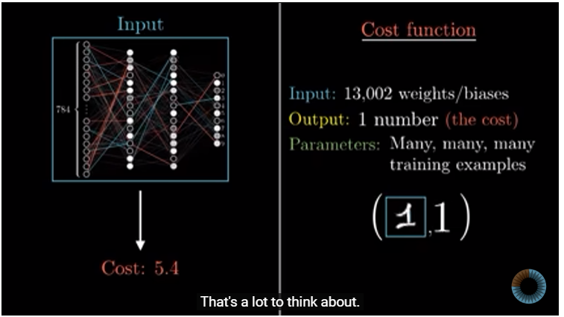

To minimize the cost function gradient descent are used here, The paramters goes to cost function should find the gradient descent, gradient descent is most lesser positive value, it takes all the weights and bias and do subtraction to find the most lesser value form that list of weights and biases
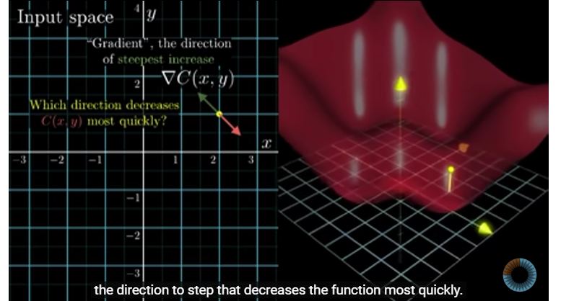

One of the algorithm that used to find the gardient descent is back probogation

NOTE: one person name called lisha li founded that networks are trained well when we give randomly labeled data instead of correct labelled data

